The Turks Head, High Street, Rothbury, 01669 620434

Christmas Fayre £29, (child’s under 12) £19

Tomato & basil soup
Prawn cocktail with classic Marie rose sauce.
Brussels pate with caramelised onion chutney.
All served with freshly baked bread.
*
Roast Turkey breast
With Yorkshire pudding, pigs in blankets, roasted potatoes - roasted parsnips & carrots with thyme & garlic, creamy mash, Brussel sprouts with bacon & chestnuts.

Our Melt in the mouth low & slow roasted Beef
With Yorkshire pudding, local pigs in blankets, roasted potatoes - roasted parsnips & carrots with thyme & garlic, creamy mash, Brussel sprouts with bacon & chestnuts

Or Duo of Turkey & beef as above

Baked fillet salmon with creamy watercress sauce.
Served with new potatoes and julienne of vegetables.

Beetroot & Butternut Squash Wellington
With red onion chutney and an assortment of seasonal vegetables.
*
Sticky toffee pudding with cream or custard
Traditional Christmas pudding with chef’s brandy sauce
Biscoff cheesecake with cream
Apple Crumble with custard or cream

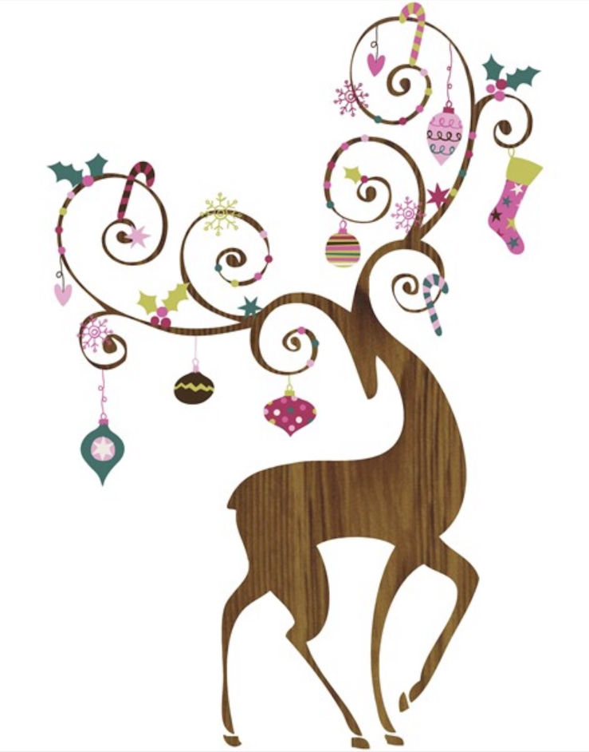
Kids starters

Chefs Soup
Home made garlic ciabatta bread

Main course as adults but smaller

Chocolate or Biscoff Sundae.
Choice of ice-creams with a flake

